Microprocessor and Computer Architecture
UE24CS251B
4th Semester, Academic Year 2025-26
Date:
Name: Harshit Chandak | SRN:PES2UG24CS185 | Section  C

LAB #____2_______ Program Number: ____1___
Title of the Program
Based on value of number in r0,
- store 1 in r1 if r0 is 0
- store 2 in r1 if r0 is positive
- store 3 if r0 is negative

- Typed ARM Assembly Code
- Three Output Screen Shots (one for each case )
( Screenshot including Register Window,Output Window and Code Window)

.DATA
NUM: .WORD 0

.TEXT
LDR R0,=NUM
LDR R0,[R0]
CMP R0,#0
BEQ ZERO
BGT POS
MOV R1,#3
B EXIT

ZERO:
MOV R1,#1
B EXIT

POS:
MOV R1,#2
B EXIT

EXIT: SWI 0x011
.END

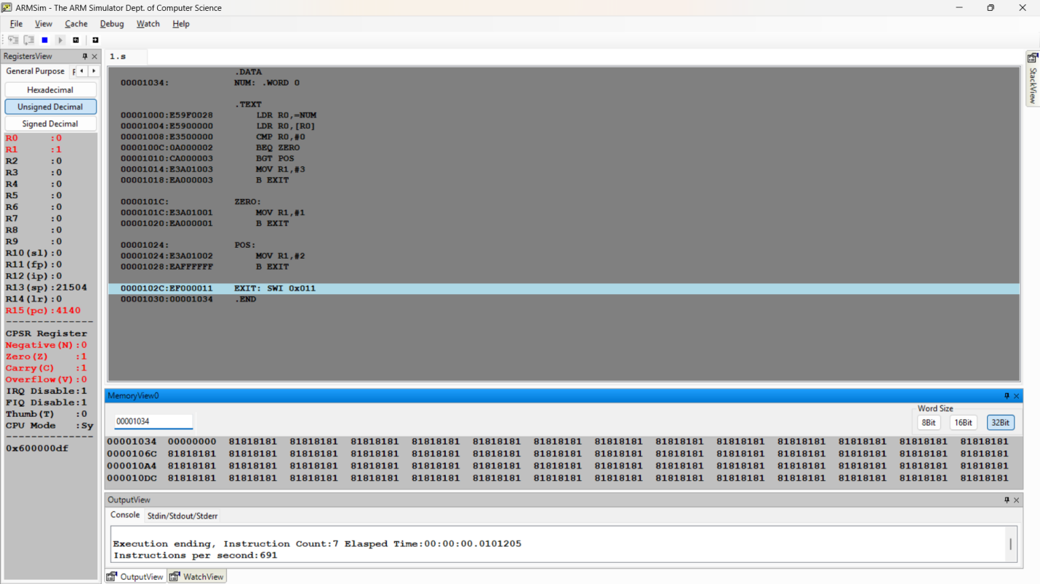

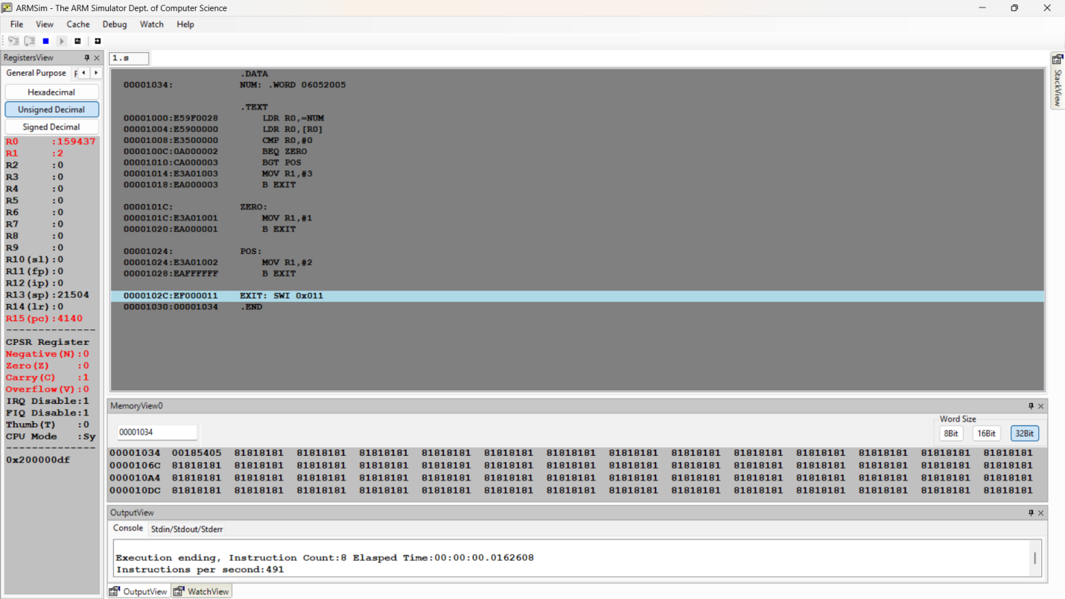

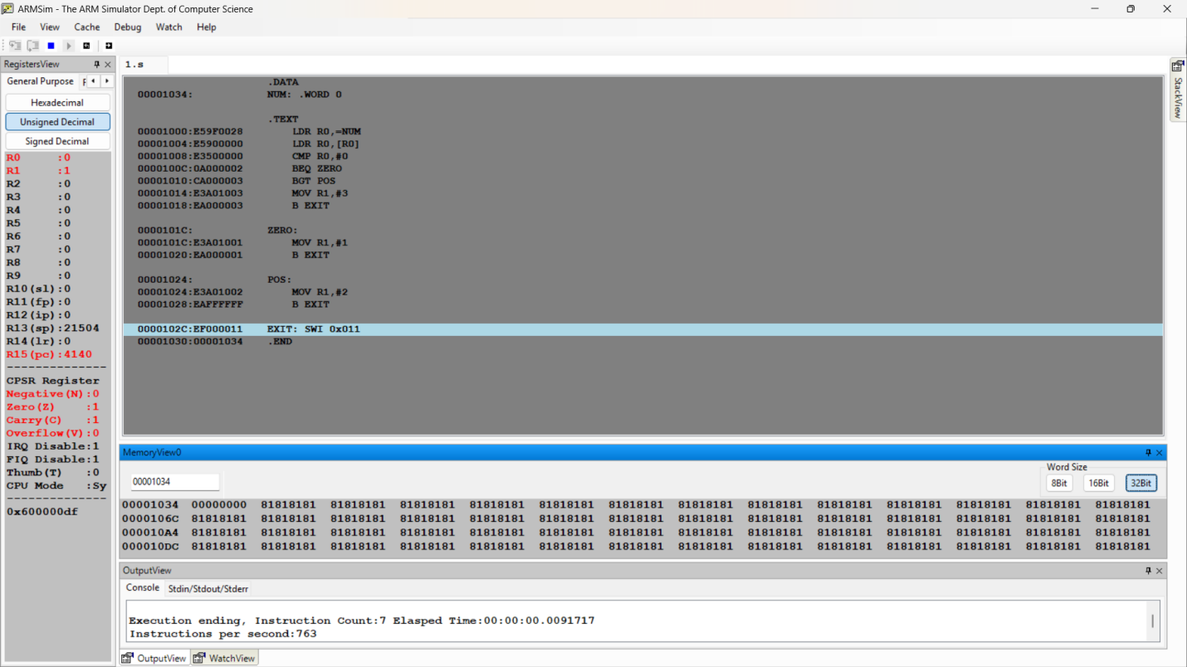

Microprocessor and Computer Architecture
UE24CS251B
4th Semester, Academic Year 2025-26
Date:
Name: Harshit Chandak | SRN:  PES2UG24CS185 | Section  C

LAB #____2_______ Program Number: ____2___
Title of the Program
Write an ARM program that generates 75 × R0 using shift and add/subtract operations (no MUL instruction).
- ARM Assembly Code
- Output Screen Shots
(One Screenshot including Register Window,Output Window and Code Window)

.DATA
A: .WORD 1

.TEXT

LDR R0,=A
LDR R0,[R0]

ADD R1,R0,R0,LSL#6
ADD R2,R0,R0,LSL#3
ADD R3,R1,R2
ADD R4,R3,R0

SWI 0x011

.END

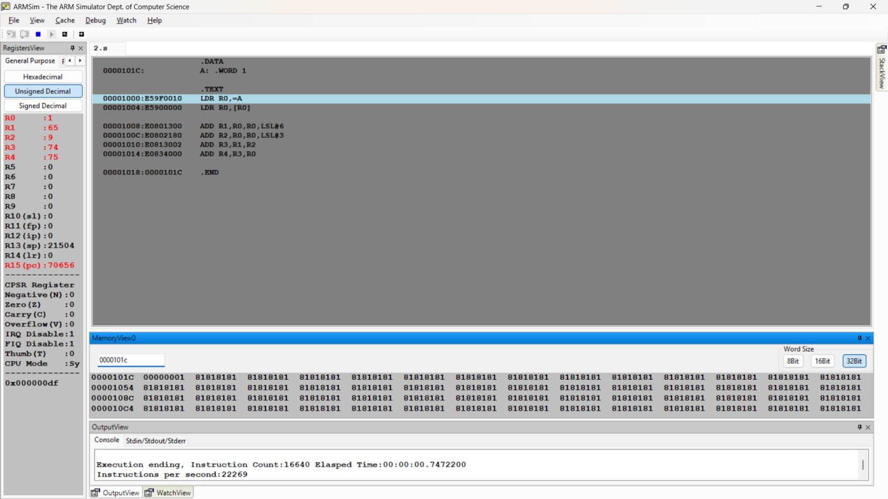

Microprocessor and Computer Architecture
UE24CS251B
4th Semester, Academic Year 2025-26
Date:
Name: Harshit Chandak | SRN:PES2UG24CS185 | Section C

LAB #____2_______ Program Number: ____3___
Title of the Program
To find GCD of two numbers using conditional instructions only.
- ARM Assembly Code
- Output Screen Shots
(One Screenshot including Register Window,Memory Window and Code Window)
.DATA

NUM1: .WORD 38
NUM2: .WORD 95

.TEXT

LDR R1,=NUM1
LDR R1,[R1]
LDR R2,=NUM2
LDR R2,[R2]

LOOP:
CMP R1,R2
SUBGT R1,R1,R2
SUBLT R2,R2,R1
BNE LOOP
BEQ EXIT

EXIT:
MOV R3,R1
SWI 0x011

.END

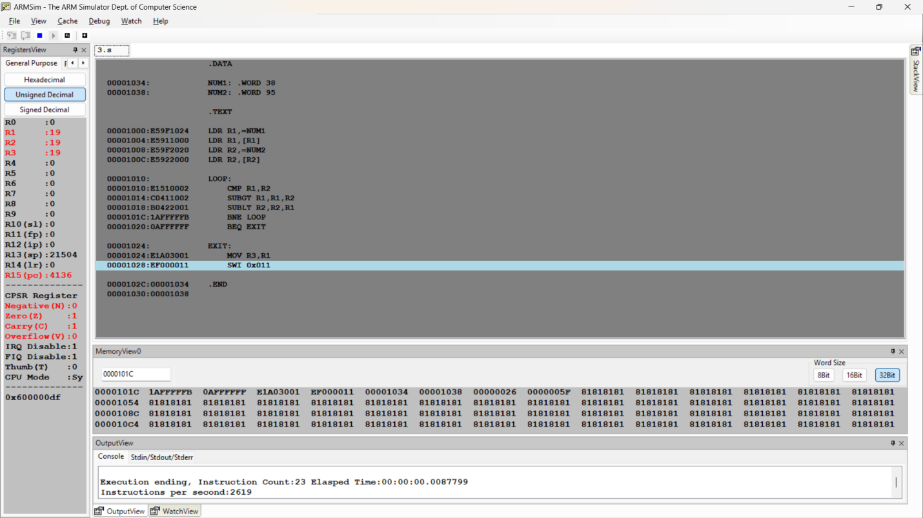
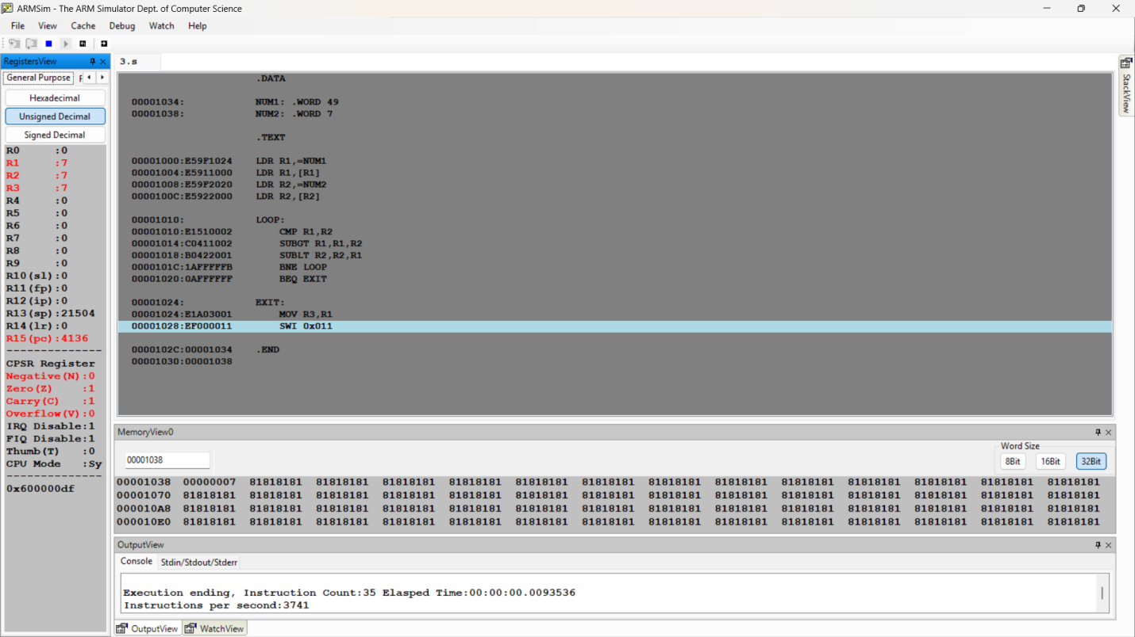
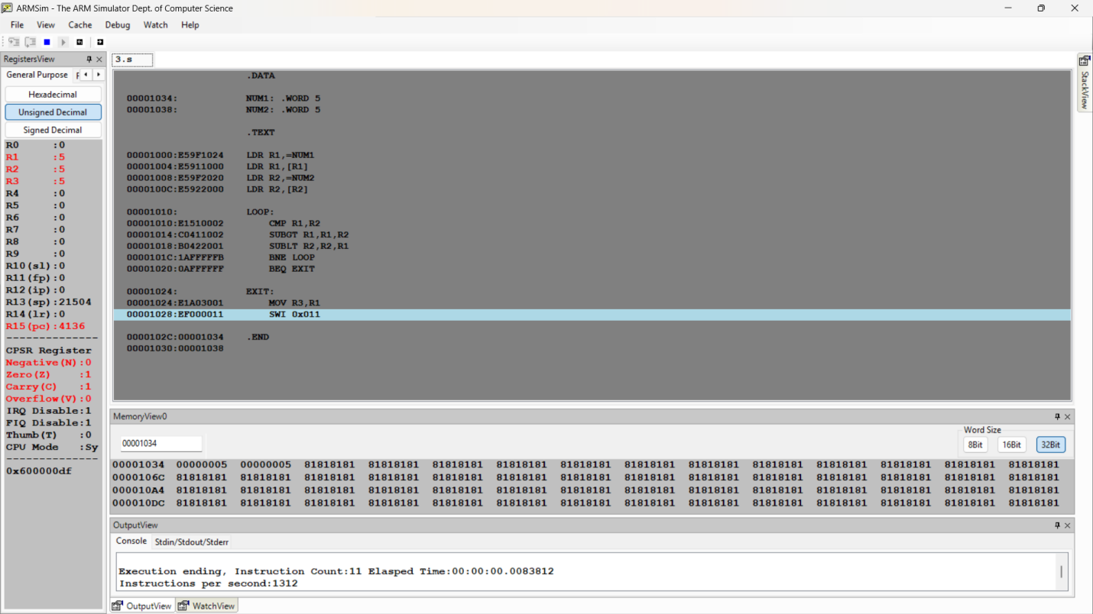

Microprocessor and Computer Architecture
UE22CS251B
4th Semester, Academic Year 2023-24
Date:
Name: Harshit Chandak | SRN:  PES2U24CS185 | Section

LAB #____2_______ Program Number: ____4___
Title of the Program
Add 2 numbers from memory and store result in memory using byte addition
- ARM Assembly Code
- Output Screen Shots
(One Screenshot including Register Window,Memory Window and Code Window)

.DATA

NUM1: .BYTE 5
NUM2: .BYTE 30
NUM3: .BYTE 0

.TEXT

LDR R0,=NUM1
LDR R1,=NUM2
LDR R2,=NUM3

LDRB R0,[R0]
LDRB R1,[R1]

ADD R3,R0,R1
STRB R3,[R2]

SWI 0x011

.END

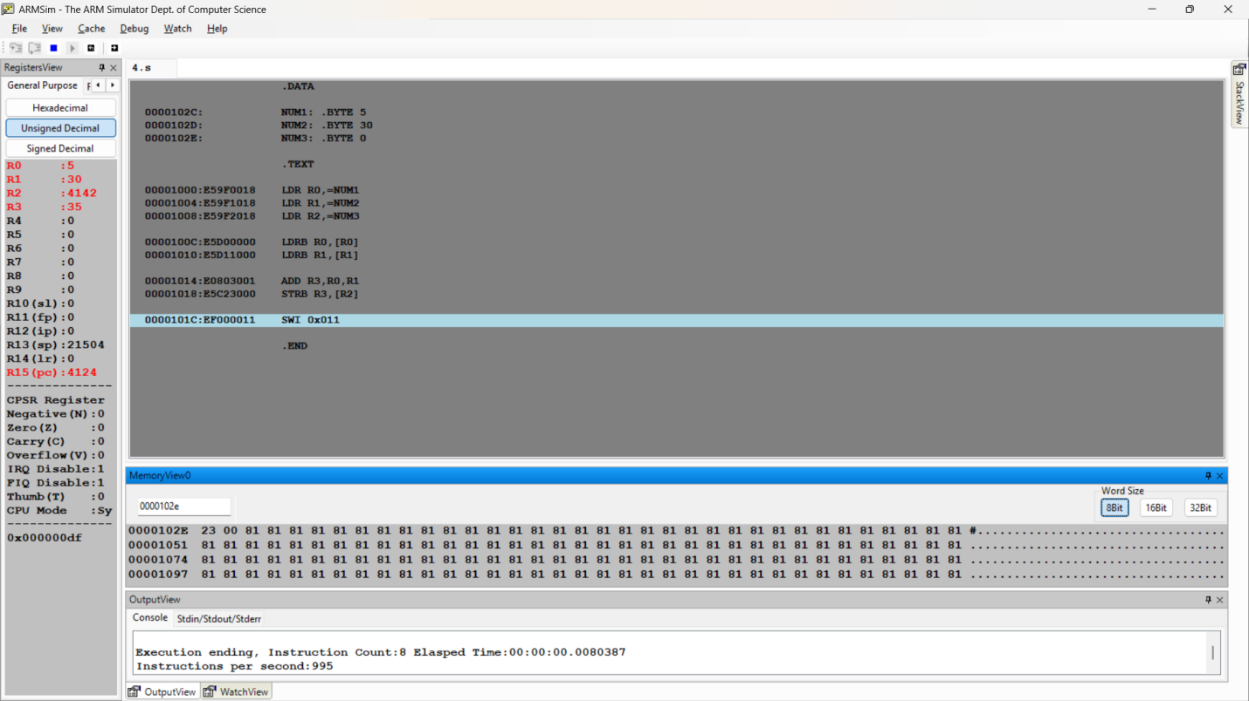

Microprocessor and Computer Architecture
UE22CS251B
4th Semester, Academic Year 2023-24
Date:
Name: Harshit Chandak | SRN:  PES2UG24CS185 | Section  C

LAB #____2_______ Assignment Question 1
Title of the Program
Write an ALP using ARM7TDMI to add only even numbers stored in memory location for a given set of numbers and store the sum in the memory location.

- ARM Assembly Code
- Output Screen Shots
(One Screenshot including Register Window,Memory Window and Code Window)
.DATA
A: .WORD 1,2,3,4,5,6,7,8,9,10
SUM: .WORD 0

.TEXT
LDR R0,=A
MOV R1,#10
MOV R2,#0

LOOP:
LDR R3,[R0]
TST R3,#1
BNE SKIP

ADD R2,R2,R3

SKIP:
ADD R0,R0,#4
SUBS R1,R1,#1
BNE LOOP

LDR R4,=SUM
STR R2,[R4]

SWI 0x011
.END

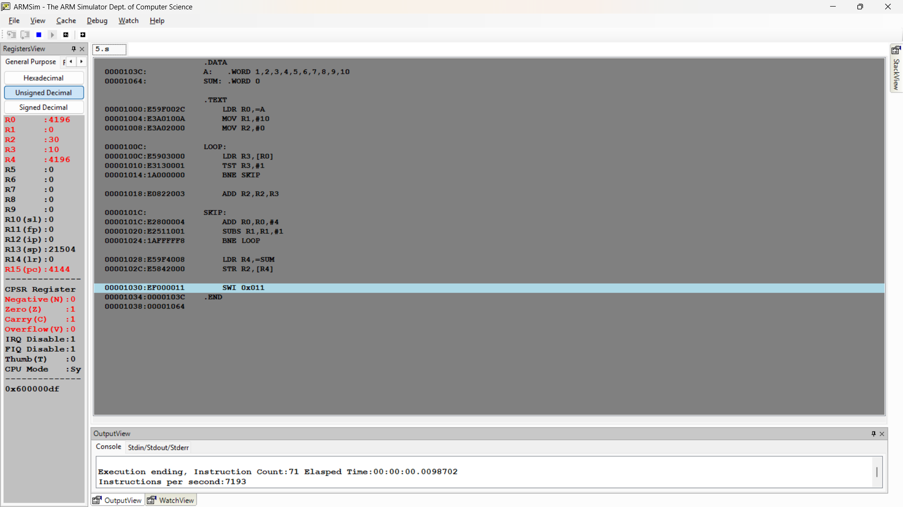

Microprocessor and Computer Architecture
UE22CS251B
4th Semester, Academic Year 2023-24
Date:
Name: Harshit Chandak | SRN:PES2UG24CS185 | Section  C

LAB #____2_______
Assignment Question 2
Title of the Program
Write an ALP to evaluate the expression (A+B) + (13*B), where A and B are available in memory location. Store the final result in memory Location C
* Use LSL instruction for multiplication
- ARM Assembly Code
- Output Screen Shots
(One Screenshot including Register Window,Memory Window and Code Window)

.DATA

A: .WORD 9
B: .WORD 6
C: .WORD 0

.TEXT

LDR R0,=A
LDR R1,=B
LDR R6,=C

LDR R0,[R0]
LDR R1,[R1]

ADD R2,R0,R1
ADD R3,R1,R1,LSL#2
ADD R4,R3,R1,LSL#3

ADD R5,R2,R4

STR R5,[R6]

SWI 0x011

.END

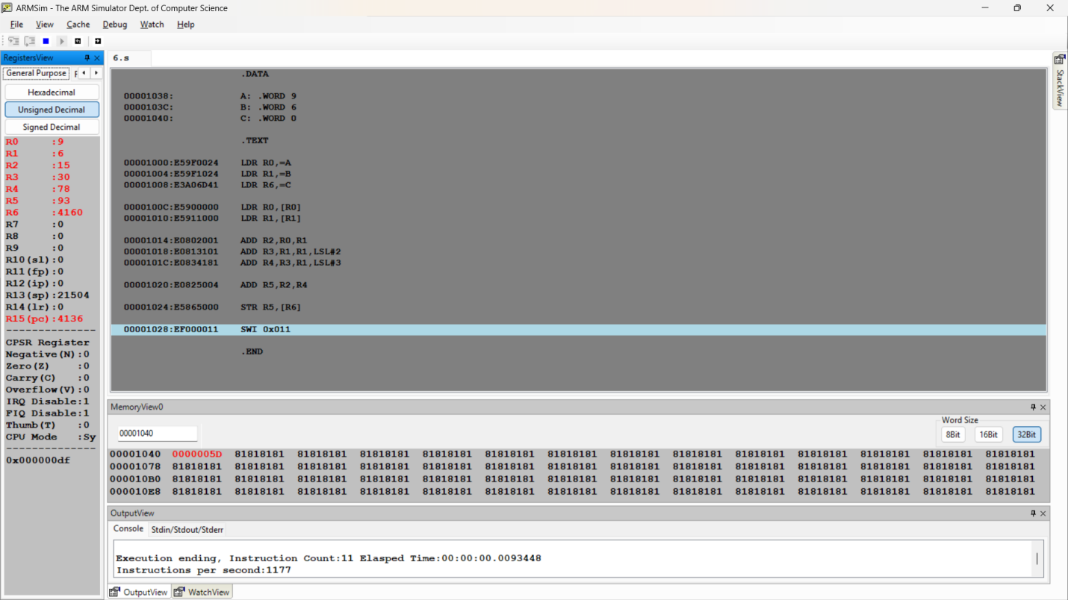

Disclaimer:
- The programs and output submitted is duly written, verified and executed by me.
- I have not copied from any of my peers nor from the external resource such as internet.
- If found plagiarized, I will abide with the disciplinary action of the University.

Signature:
Name:
SRN:
Section:
Date:

